Strategies for communicating with children who may be feeling overwhelmed

It is acknowledged that children who may not be fully emotionally literate or may be on the ASD spectrum get overwhelmed easily. At this point it is important to use some communication rules.
An acronym used as a strategy is:
Keep
It
Short &
Simple

Use of language:
- Provide instructions which start with the child’s name so that they are aware that they are being spoken to
- Provide short, chunked communication
- Use concrete or literal language
- Use a positive e.g. ‘walk’, as opposed to ‘don’t run’
- Direct the child
- Any use of new words must only be done once the word has been taught or explained
- Allow processing time – leave 30 seconds after a question or direction, if no response is given then repeat the same question or direction and wait 30 seconds again. Try this 3 times and if there is still no response then consider using different language or visual aids.
- Make peer communication planned and unstructured
- If children are within named groups also use the name of the child to ensure that they know that they are included in the direction

How to develop social skills:
- Use small group activities
- Social stories (search for “Carol Grey” on your internet browser for an example of these)
- Teach children how to take turns
- Name emotions so that these can be recognized
- Be a role model in interactions

Consider the senses:
- These include hearing, sight, touch smell and tastes along with balance, motion and movement, and body awareness
- Children can be overloaded with sensory information or not be able to process this which can lead to non-recognition of danger, or not feeling any pain
- Find the child’s preferences and what they struggle with and act accordingly
- Allow movement breaks, allocate the child a job to use muscle groups

Is the environment appropriate?
- Consider clutter/too much on the walls/noise/touch
- Provide diaries or lists
- Provide visual timetable and ‘what ifs’
- Use mind maps to help children link concepts
- Provide a structured point in the day for a child to carry out their routine or talk about what interests them
- Provide minimal choices within a structure
- Teach play skills

Visuals:
- This involves putting an instruction into a picture format.
- Search for ‘visual timetables’ on your internet browser to find ideas to use

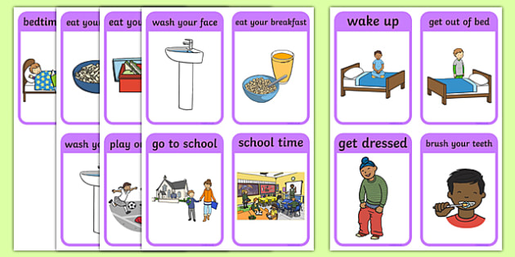

- Visuals like the ones shown above are used often because they:
  - help a child feel secure
  - reduce anxiety
  - support spoken language
  - are predictable and can support routine
  - can help the transition between activities
  - can prepare for change

Most of all – be supportive of different behavior and prompt children to use their calming down strategies. Behaviour is used to communicate emotions and can be a solution to a problem (e.g. running away/hiding).

We have to find out what that problem may be!

