Guided mindfulness readings
These should be read to children/young adults in a low, soothing, monotone voice. Encourage the child/young person to get into a comfy position first.

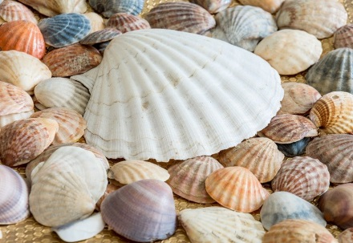
The magic shell meditation (from Meditations for Mini’s by Debbie Wildi)
This script is for younger children and can help when worries and anxiety are a concern.
Place yourself in a comfy, cozy position. Close your eyes and take a long slow deep breath. As you breathe out relax your body.
Imagine that you are standing on a beach. See the beach in your mind. Think about a beach that you may have visited, or you could use an imaginary beach if you like.
You can feel the sand beneath your toes and the sun is warm on your face. Look around you. In front of you is a huge ocean. It looks a silvery-blue colour and the sunlight sparkles like tiny stars dancing on the surface.
You look at the ground and in front of you in the sand is the most glorious shell you have ever seen. You pick it up. It feels warm. Notice how smooth the shell is. Feel it with your fingers. This is your magic shell. You can tell it your secrets and it will keep them. You can also tell your shell any worries that you may have. Tell it about any problems that may be troubling you at the moment. No matter how big or how small they are. The shell wants to hear them.
Whenever you have worried feelings you can tell your shell about them and it will magically take those horrid feelings and turn them into good ones.
Now see yourself holding the shell close to your mouth. In your mind silently tell it whatever you wish. No one else will know what you say. Only you and your shell! As you say your words they go right into the middle of the shell so that it can take them away for you. Tell your shell your worries right now….
Now you do not have to feel yucky feelings anymore. The shell has made them disappear. Just like magic!
They are gone!
As you hold your shell close all you feel is calm and happiness. You feel peaceful all the way from the tips of your toes, to the tip of your nose. Feel it right now. Notice how it feels.
It is important for you to know that you can imagine your shell whenever you wish to make yucky thoughts and feelings disappear, whenever you wish to feel calm. Your shell will always be there waiting in your imagination.
Of course, if you visit the seaside you can always look for your own real magic shell. How will you know it is magic? Just choose the shell that feels right for you, this will be the magic one. You can also use a magic stone if you like.
Find one of these in your garden, or in the street.
Here is an idea! Keep your magic shell or stone under your pillow to take away bad dreams and always bring you a peaceful sleep. Perfect!!

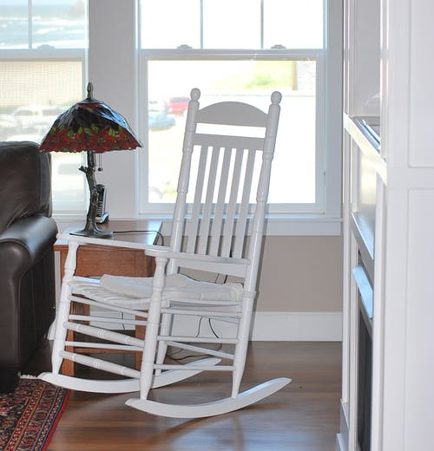
The big white house (from Guided Imagery for Healing Children and Teens by Ellen Curran)
This script helps older children and teens to gain perspective and deal with everyday stress.
Imagine walking along a long white beach. You can hear the gulls and the gentle roll of the waves. Your feet sink into the warm, white sand. It is quiet and safe. You are alone walking into the soft sea wind. The sun is shining down on you, making you warm. You have been looking for a place to be quiet and comfortable. This feels as if it is your beach, yours alone.
You stop and stand, looking out over the immense expanding ocean. It shows its green top-water, its purple mid-water, and its grey powerful underwater. The colours are mixing and churning, creating the bubbly white crest at the top of each wave. The roll of each wave sounds like the Earth, breathing. O…cean. O…cean. Over and over again with each wave. You feel the power of the ocean and the Earth.
A short distance ahead of you, you now notice a big, white house. It is beckoning to you. It looks like a temple or small castle of some sort. You walk towards it, relaxed and interested. Your follow a short path to the house and see that the large door is open. Your feel that it is perfectly OK for you to go inside. It is safe and calm.
You step out of the sunshine and into the coolness of this beautiful house. You find yourself in a huge hallway with plants and paintings. A magnificent, marble staircase stands before you. You know you want to go up those stairs. You become aware of a very heavy backpack that you have been carrying all this time. The backpack is full of your worries, troubles, concerns, and negative feelings. You have been carrying them for a long time and you realize that this backpack is weighing you down. Your shoulders ache, and your back feels tight and stiff from all these feelings.
Slowly remove your backpack and with it all your worries and concerns. You feel released, free! You can now easily ascend the staircase. Each step you take, you become lighter, happier, and quieted. Each step brings you closer to absolute comfort and joy. The comfort and joy live in you, and now there is nothing to get in the way of feeling them, reaching them, having comfort and joy.
Now at the top of the stairs, you are strong and certain. A large window is open at the top of the stairs, and in front of it is a big, white comfortable chair. You sit down and face the window, watching the magnificent ocean once again. This time is yours. You watch from your chair, by your window in your house. Breathe in the soft ocean air, and know you are home.”

