Help When Experiencing Panic Attacks
What can cause a panic attack?
Although we do not know for 100% certain the cause of a panic attack, the following are factors:
- Major stress
- Change
- Genetics
- Brain Function
A panic attack can come on suddenly and you may feel as if there has been no warning but over time it may be that you can identify emotions or situations which may trigger a panic attack.
What does a panic attack feel like?
When experiencing a panic attack the body can go into the ‘fight or flight’ response which results in many physiological changes (these are listed under ‘symptoms’ on the panic attack plan). Symptoms of a panic attack can build and appear very quickly, some of these include:
- Racing heartbeat
- Dizziness
- Felling sick
- Very hot or very cold
- Shaking legs
- Shortness of breath
- Pain in the chest
- Chattering teeth
Strategies to try in a panic attack
There are many strategies to try but different ones will be more effective for different people.
Following is some of the easier ones because when in the middle of a panic attack we often forget what may help us.
- Try to stay where you are during the panic attack if it safe to do so- acknowledge your thoughts and accept that your body is doing what it needs to do and keeping you safe- there is nothing to fear.
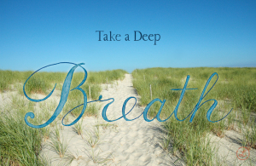
- Use deep breathing techniques. In through the nose and out through the mouth. Imagine sniffing a strawberry and then blowing a candle out.

- Close your eyes when trying to focus on your breathing- this reduces the amount of external stimuli.
- Learn some positive coping statements, for example- this will pass, this will not last forever, panic is anxiety, there is nothing to fear, I do not need to escape, I have never fainted or had a heart attack.

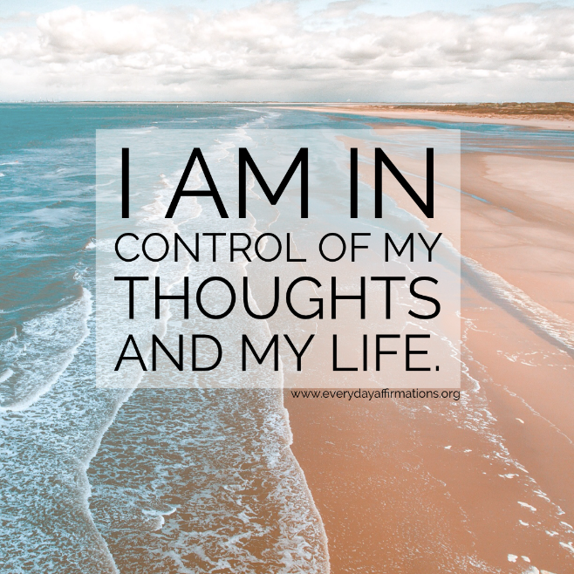

- Challenge your unhelpful and negative thoughts, for example, if you think that you are going to have a heart attack remind yourself that you have felt like this before and that did not happen, also remind yourself that the calmer you become, the more the physical feelings will lessen.
- Think of your happy place. Imagine being at a place where you have been calm, relaxed and happy. For some people this may be in nature, it may be a certain room in the home or may be a holiday destination.

- Muscle relaxation- this has similar effects to deep breathing. Consider each part of your body and relax each muscle in turn.
- Make a panic attack plan and have this to hand- you will be reminded of the symptoms you have felt before and what strategies helped previously.

Panic Attack Plan
What were you thinking about before your most recent panic attack?
How were you feeling before the panic attack?
What were you doing before the panic attack?
Circle your symptoms:
Pounding or racing heart | Difficulty breathing | Sweating
A sense of terror or impending doom | Feeling dizzy/faint/lightheaded | Feeling detached from yourself or the here and now
Feeling like you’re  “going crazy” | Nausea/feeling sick | Chest pain or discomfort
Choking sensation | Chills or feeling of heat | Numbness or tingling
Trembling or shaking | Any other

What makes me calm down when I am feeling panic?

Example Panic Attack Plan
What were you thinking about before your most recent panic attack?
Me and my friend had been talking about going back to school and then when I was alone I started thinking about this and started to get worried
How were you feeling before the panic attack?
I could feel that my heart was starting to race and my hands were getting all sweaty
What were you doing before the panic attack?
I was thinking about going back to school and then I started to pace around the room and was breathing really fast
Circle your symptoms:
Pounding or racing heart | Difficulty breathing | Sweating
A sense of terror or impending doom | Feeling dizzy/faint/lightheaded | Feeling detached from yourself or the here and now
Feeling like you’re  “going crazy” | Nausea/feeling sick | Chest pain or discomfort
Choking sensation | Chills or feeling of heat | Numbness or tingling
Trembling or shaking | Any other  Racing heart and fast breathing

What makes me calm down when I am feeling panic?
I could understand why I was feeling light headed and dizzy, because I was breathing too fast. I concentrated on slowing my breathing down and distracted myself by colouring.

Apps which may help:
- Calmharm
- Superbetter
- Calm
- Headspace.
Websites:
- Young minds
- Open Minds in Calderdale
Resources used:
- Therapistaid.com
- Mind.org.uk
- Mayoclinic.org

