Mindfulness activities

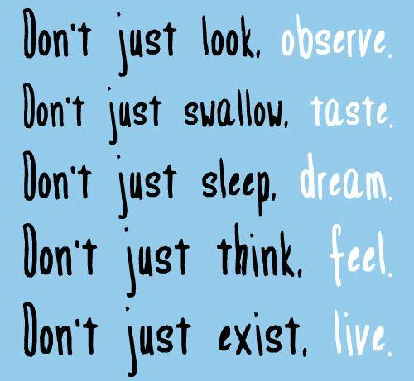
What is Mindfulness?
This means paying attention to the present moment. It helps because we can see inside our head and see if what we think is reality or not – this stops us getting carried away and gives us control and the power to choose how we react.
This place, where we can go in our mind, to be still, is always there – when we are angry or happy or frustrated or anxious.

Activities to help practise mindfulness:

- Mindfulness Minute
Play an alarm for 30 seconds and ask children to listen to it.
Ask them to continue listening until it stops.
Then listen for one minute after, to see what people could hear.
This is turning the focus on to the here and now.

- To bring the mind to here and now
Notice:
5 things you can see
4 things you can touch
3 things you can hear
2 things you can smell
1 thing you can taste

- Hand breathing
Ask the child to hold out their hand like and star and then trace up and down their thumb and fingers with the opposite index finger.
They should work up the thumb/finger on an in breath, pause at the top and work back down on an out breath and repeat.

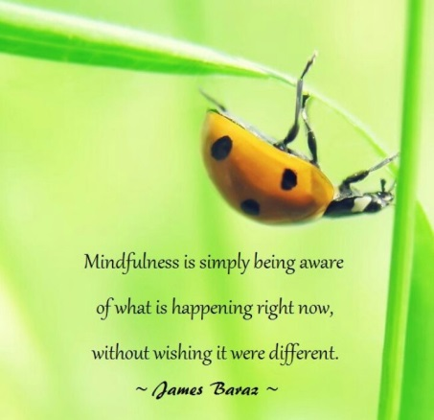

Apps for mindfulness
- Headspace
- Calm
- Superbetter
- Feeling Good

