Young People and Sleep
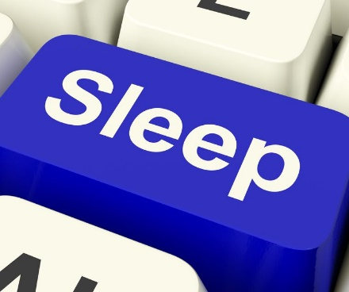
Sleep is extremely important for everyone and at different ages we are advised we need different amounts of sleep.
As young people enter adolescence it is stated by the sleep foundation that they need 8 to 10 hours of sleep a night.
You may also have noticed that in adolescence young people’s sleep patterns change. They become more awake later into the evening and also sleep later into the morning, this is related to the biological clock rather than an actual choice.
Sleep is even more of an issue during the Covid-19 pandemic where people have had their type and amount of activities changed and may therefore be sleeping very different hours.
To help young people get back into a good sleep routine we are going to consider ‘sleep hygiene’ and also how sleep can help with common problems, such as spots, moods and energy.

Sleep Hygiene:
This is all about making the environment as comfortable for sleep as possible. Think about the following:
- Is it the right temperature? Too warm or too cold makes sleep difficult
- Is it too bright? It may be worth considering a black out blind or black out curtains
- Is it over stimulating? Consider what is on the walls? What is on the shelves? Is there too much colour and too much to look at. Consider having somewhere to move things to so that they are out of sight.
- Is it noisy? Can you hear the tv from downstairs? Is the room next door to a noisy sibling? Consider making changes if you can. An idea is to fall asleep to mindful music.
- Can you see a clock? Being able to see time can cause us to overthink and work out ho long we have been trying to sleep and how long we have left- this is not good so the clock should be out of sight. This includes not checking it on a mobile phone or tablet.

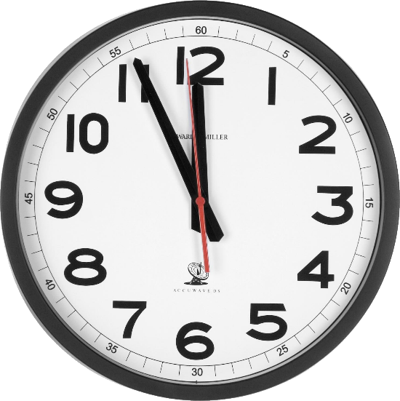

Things to improve sleep:
There are some things we could all do to improve our sleep pattern and quality. Think about the following:
- Screen time- we know the evidence that staring at a phone or tablet screen prior to sleeping interrupts melatonin production (sleep hormone). It’s a good idea to put screens down at least half an hour before planning to fall asleep.
- Exercise- it’s a good idea to get exercise during the day bit do not do this too close to bedtime as sometimes it can interrupt with falling asleep.
- Caffeine- caffeine can prevent sleep so it’s important to reduce your intake- this includes energy drinks!
- Binging- eating a light supper before bed is sensible but do not try to go to sleep on a heavy meal. Some foods which promote sleep are bananas, almonds and turkey.
- Routine- it is much easier to sleep when following the same sleep and wake routine. It is also a good idea to have a warm bath and warm drink before bed.
- Talking- we all have some worries, it is important to talk about these so that they do not interrupt or affect your sleep.
- Weekend lie ins- As tempting as these are they can result in a ‘jet lag’ feeling on a Monday when you have to be up earlier and have had less sleep than usual due to going to bed later.

Benefits of good quality sleep
Getting a good sleep not only makes us feel better but it also has these positive effects:
- Spot free- maintaining a good sleep routine prompt less spots
- Healthy weight- good sleep helps young people to maintain a healthy weight
- Growth- it’s true that we grow as our body sleeps and recovers
- Energy- to have plenty of energy you should also have enough sleep
- Memory- having the correct amount of sleep helps young people remember their learning
- Concentration- sleep helps young people concentrate in school
- Mood- with good quality sleep comes a better mood.
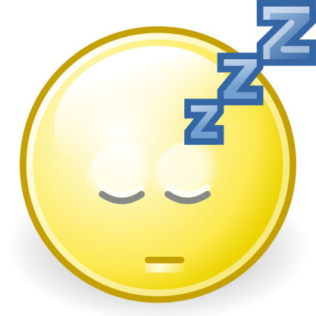

Sleep and Preparation for Back to School
It has been a funny few months for everyone, adults and school children alike.
We have had to learn to use technology, learn to home school and learn to stay motivated when a lot is going on around us.
Our routines have changed and I do not doubt that our sleep patterns have also changed.
So how do we get back into a good sleep pattern for school?
- Sleep hygiene- consider the tips above
- Bedtime routine- again consider the tips above
- Time changing- it is impossible to go from your sleep time being 1am to it being 9pm in one day. It is advised that the sleep time is moved backwards by 30 minutes over a period of time until the preferred time has been reached. So although it is the school holiday’s changes need to be made now so ensure you go back to school refreshed and ready to learn.

