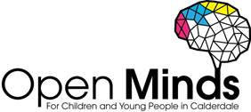
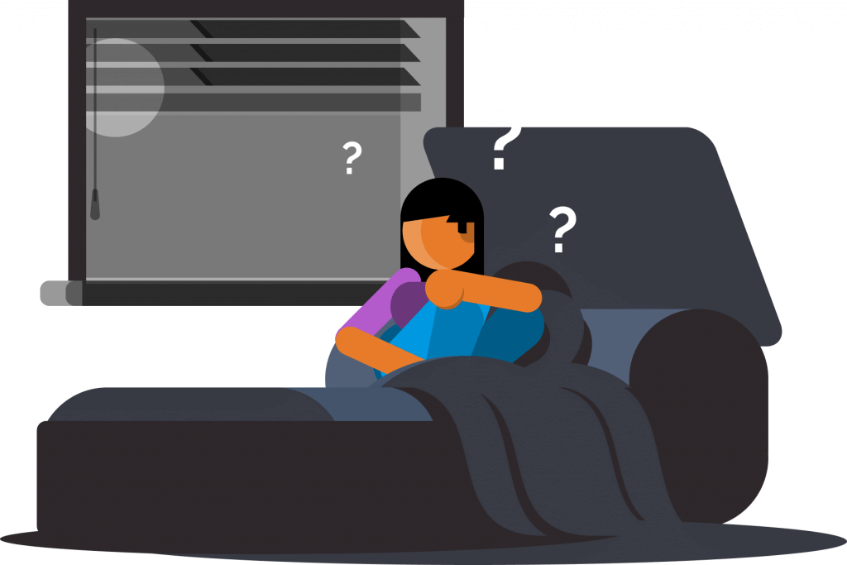

Supporting Children and Young People who are Expressing Suicidal Thoughts

Signs and symptoms to look out for:
Are they…?
- Expressing that they wish they were dead
- Withdrawing themselves from situations
- Feeling useless, worthless or expressing self-loathing
- Worried, anxious or restless
- Lacking motivation
- Fixated with death

As a trusted adult you can provide support just by listening and valuing the feelings the child/young person is expressing; these thoughts and feelings should always be explored. Talking about suicide does not make it more likely to happen. Here is a useful 1-page guide to help you with these conversations.
You could also suggest the following tips and useful resources:
- Here are some frequently asked questions (FAQ)
- A good idea is to make a safety plan
- Here are some coping strategies
- Distraction techniques can be useful
- A hope box filled with things that can help you to feel better

It’s important to encourage children and young people to speak to a professional who can also help (e.g. a GP, counsellor, or helpline). Here is a list of local support services for children and young people:
Open Minds (CAMHS) offer specialist mental health support for children and young people.

- Age range: 5-18 years
- Referral process: online referral form
- Contact details: 01422 300 001
- Opening times: Monday – Friday 9am – 4.30pm (open until 6pm on Tuesdays & Wednesdays in term time)

Noah’s Ark Centre offers counselling/psychotherapy to young people and therapeutic play to children aged 5-11.

- Age range: 5-21 years
- Contact details: 01422 300457 to find out more and make a referral
Papyrus offers free confidential advice and support for children and young people struggling with suicidal thoughts. Its helpline service HOPELINEUK is available to anybody under the age of 35 experiencing suicidal thoughts, or anybody concerned that a child or young person could be thinking of suicide.

- Age range: under 35 years
- Opening times: 9am – midnight, 365 days a year
- Contact details: 0800 068 4141 Text: 07860039967 or email: pat@papyrus-uk.org

Kooth is a free, safe, anonymous online counselling and support service. Young people can access Kooth’s counselling service, self-help resources, peer to peer forums and interesting articles written by young people for young people.
- Age range: 10-25 years
- Referral process: self-referral
- Opening times: until 10pm every evening, 365 days a year

Childline offers free confidential support over the telephone or online with a 1-1 councillor. No problem is too big or small.

- Age range: under 19
- Contact details: 0800 1111
- Opening times: 7.30am - midnight - Monday to Friday, 9am - midnight - Saturday to Sunday 365 days a year

Barnardo’s Positive Identities Service provide direct support to LGBTQ children and young people around their gender and sexual identities. They also work with parents/carers and families.
- Age range: 8-21 years
- Contact details: positive.identities@barnardos.org.uk to find out more and make a referral

YoungMinds Crisis Messenger provides free, text support for young people across the UK experiencing a mental health crisis. All texts are answered by trained volunteers.

- Age range: under 25
- Contact details: text YM to 85258
- Opening times: 24 hours a day 7 days a week

Advice for parents and carers:

Is your child expressing suicidal thoughts? This leaflet provides parents and carers with some top tips, useful resources, and links to local support services here in Calderdale.

Suicide Awareness Training for Staff
- Zero Suicide Alliance offer free online suicide awareness training giving the participant the skills and confidence to help someone who may be considering suicide.

- safeTALK is a half day training programme that prepares participants to identify people with thoughts of suicide and connect them to suicide first aid resources.

