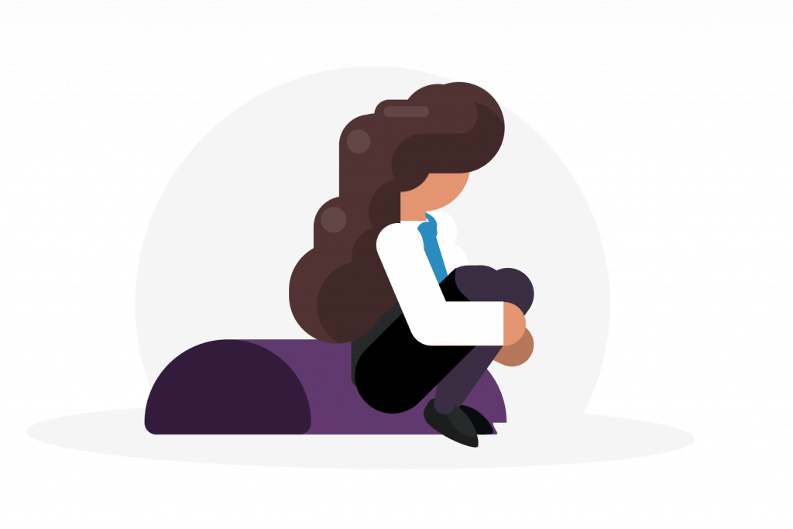
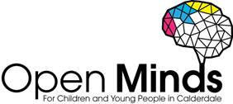

Supporting Children and Young People who Hurt or Harm themselves

Signs and symptoms to look out for:
Have they…?
- Got unexplained bruises, sores, cuts or burns
- Become withdrawn
- Experienced a change in behaviour
- Shown signs of low mood, depression, worry or anger
- Expressed self-blaming feelings of failure, hopelessness, or says they are useless
- Avoided swimming or changing clothes around others

As a trusted adult you can provide support just by listening and valuing the feelings the child/young person is expressing.
You can suggest the following tips and useful resources:
- How do I tell someone I self-harm?
- Make a self-harm action plan.
- Try distraction techniques to help you divert the habit.
- Suggested coping techniques by ChildLine
- A leaflet for young people on self-harm
- Five Finger Breathing, a simple guided breathing exercise.
It’s important to encourage children and young people to speak to a professional who can also help (e.g. a GP, counsellor, or helpline). Here is a list of local support services for children and young people:

Open Minds (CAMHS) offer specialist mental health support for children and young people.

- Age range: 5-18 years
- Referral process: online referral form
- Contact details: 01422 300 001
- Opening times: Monday – Friday 9am – 4.30pm (open until 6pm on Tuesdays & Wednesdays in term time)

Noah’s Ark Centre offers counselling/psychotherapy to young people and therapeutic play to children aged 5-11.
- Age range: 5-21 years
- Contact details: 01422 300457 to find out more and make a referral
Kooth is a free, safe, anonymous online counselling and support service. Young people can access Kooth’s counselling service, self-help resources, peer to peer forums and interesting articles written by young people for young people.
- Age range: 10-25 years
- Referral process: self-referral
- Opening times: until 10pm every evening, 365 days a year

The BREW Project delivered by Invictus Wellbeing offers children and young people who present with personal, social, emotional concerns to access bespoke support sessions.
- Age range: 5-17 years
- Referral process: online referral form
- Opening times: Monday to Friday, 9am-5pm (referrals only)
- Contact details: 01422 730015 or support@invictuswellbeing.com

Time Out delivered by Healthy Minds helps children and young people ‘find their thing’, through activities such as arts, crafts, sports, singing and drama sessions. Time Out also has a Listening Line which provides support and advice for students. Text 07418 311736. They offer three sessions with a project worker to talk through worries.
- Age range: 10-19 years
- Referral process: self-referral
- Contact details: 01422 345154 or timeout@healthymindscalderdale.co.uk

Barnardo’s Positive Identities Service provide direct support to LGBTQ children and young people around their gender and sexual identities. They also work with parents/carers and families.
- Age range: 8-21 years
- Contact details: positive.identities@barnardos.org.uk to find out more and make a referral

Advice for parents and carers:
Is your child harming or hurting themselves? This leaflet provides parents and carers with some top tips, useful resources, and links to local support services here in Calderdale.

Free training offer for staff and students:
- Training workshops are available for school staff around EHWB. This is delivered by Open Minds (CAMHS) training@calderdalecamhs.org.uk
- Training workshops are available for students around EHWB. This is delivered by Healthy Minds, Time Out Tara@healthymindscalderdale.co.uk
- Training workshops are available for the wider workforce around EHWB. This is delivered by Open Minds (CAMHS) training@calderdalecamhs.org.uk

