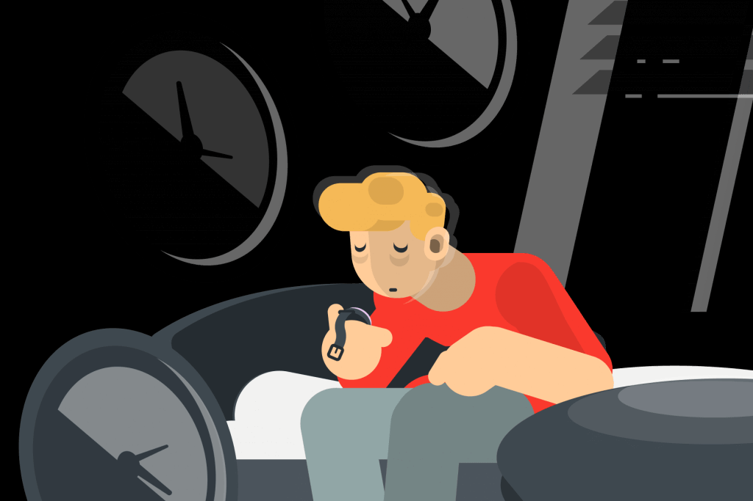

Supporting children and young people with their routine after lockdown

Signs and symptoms to look out for:
Are they …?
- Displaying different behaviours and emotions
- Bad-tempered and irritable
- Struggling with their sleep
- Sluggish and unmotivated
- Tearful
- Moody
- Skipping meals
- Worried or nervous
- Exhausted, fatigued, or just tired

As a trusted adult you can provide support just by listening and valuing the feelings the child/young person is expressing.
You can suggest the following tips and useful resources:
- Setting an alarm in the morning helps add structure to the day.
- Eating breakfast gives students an energetic boost to start their day.
- Encouraging a consistent bedtime, a good night’s sleep is important.
- Going to bed 15 minutes early to unwind and relax before going to sleep.
- Limit time on devices before bed helps relax their mind.

Free local support services for children and young people:
Time Out delivered by Healthy Minds helps children and young people ‘find their thing’, through activities such as arts, crafts, sports, singing and drama sessions. Time Out also has a Listening Line which provides support and advice for students. Text 07418 311736. They offer three sessions with a project worker to talk through worries.
- Age range: 10-19 years
- Referral process: self-referral
- Contact details: 01422 345154 or timeout@healthymindscalderdale.co.uk

The BREW Project delivered by Invictus Wellbeing offers children and young people who present with personal, social, emotional concerns to access bespoke support sessions.

- Age range: 5-17 years
- Referral process: online referral form
- Opening times: Monday to Friday, 9am-5pm (referrals only)
- Contact details: 01422 730015 or support@invictuswellbeing.com

Kooth is a free, safe anonymous online counselling and support service. Young people can access Kooth’s counselling service, self-help resources, peer to peer forums and interesting articles written by young people for young people.
- Age range: 10-25 years
- Referral process: self-referral
- Opening times: until 10pm every evening, 365 days a year

ChatHealth, Healthy Futures Calderdale is an NHS-approved secure and confidential text messaging support service for young people.
- Age range: 11-19 years
- Referral process: self-referral
- Contact details: text: 07480 635297

C&K Careers CHAT is a support, advice and guidance service to young people and their parents/carers. CHAT has friendly advisers who will listen and support young people with college or sixth form, future options, CVs and interviews, employment skills, worries and much more.
- Age range: 13-24 years
- Referral process: self-referral
- Opening times: Monday to Friday, 9am-5pm
- Contact details: 01484 213856 or chat@ckcareers.org.uk

Advice for Parents and Carers:
Is your child finding the back to school routine difficult? This leaflet provides parents and carers with some top tips, useful resources, and links to local support services here in Calderdale.

Free training offer for staff and students:
- Training workshops are available for school staff around EHWB. This is delivered by Open Minds (CAMHS) training@calderdalecamhs.org.uk
- Training workshops are available for students around EHWB. This is delivered by Healthy Minds, Time Out Tara@healthymindscalderdale.co.uk
- Training workshops are available for the wider workforce around EHWB. This is delivered by Open Minds (CAMHS) training@calderdalecamhs.org.uk

