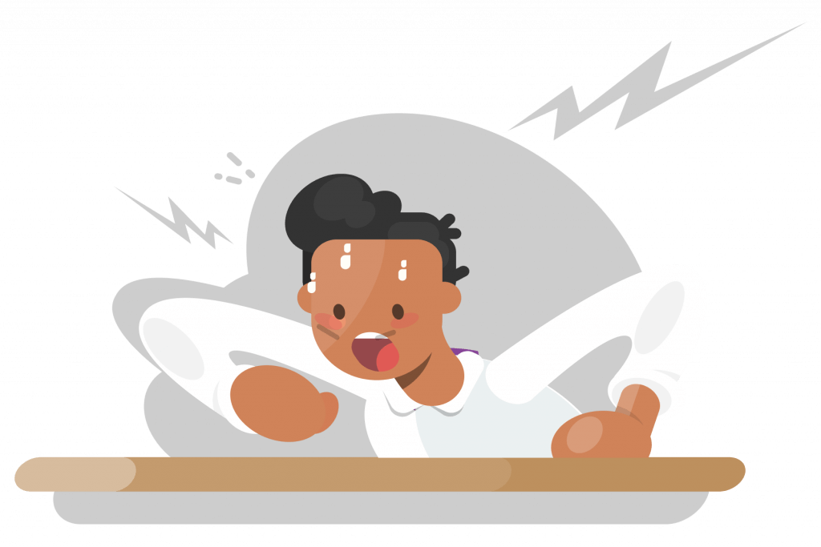
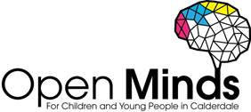

Supporting Children and Young People who feel Angry

Signs and symptoms to look out for:
Do they…?
- Tense their muscles and find it hard to relax
- Have moments of feeling hot or sweaty
- Clench their fists or teeth
- Hit themselves or others
- Get tightness in their chest
- Tremble/shake

As a trusted adult you can provide support just by listening and valuing the feelings the child/young person is expressing.
You can suggest the following tips and useful resources:
- Being active is great for your body and mind, it releases endorphins ‘happy chemicals’ that make you feel good.
- Five Finger Breathing, a simple guided breathing exercise.
- We all feel angry sometimes, often when there’s a good reason. Uncontrolled anger can be harmful, but you can learn to manage it.
- Mindful activities to help you calm down
- Mindfulness and calming strategies
- Coping with anger including top tips and strategies
Local support services for children and young people:
Kooth is a free, safe, anonymous online counselling and support service. Young people can access Kooth’s counselling service, self-help resources, peer to peer forums and interesting articles written by young people for young people.
- Age range: 10-25 years
- Referral process: self-referral
- Opening times: until 10pm every evening, 365 days a year

The BREW Project delivered by Invictus Wellbeing offers children and young people who present with personal, social, emotional concerns to access bespoke support sessions.

- Age range: 5-17 years
- Referral process: online referral form
- Opening times: Monday to Friday, 9am-5pm (referrals only)
- Contact details: 01422 730015 or support@invictuswellbeing.com
Noah’s Ark Centre offers counselling/psychotherapy to young people and therapeutic play to children aged 5-11.

- Age range: 5-21 years
- Contact details: 01422 300457 to find out more and make a referral

Time Out delivered by Healthy Minds helps children and young people ‘find their thing’, through activities such as arts, crafts, sports, singing and drama sessions. Time Out also has a Listening Line which provides support and advice for students. Text 07418 311736. They offer three sessions with a project worker to talk through worries.
- Age range: 10-19 years
- Referral process: self-referral
- Contact details: 01422 345154 or timeout@healthymindscalderdale.co.uk

Calderdale School Nursing Team Identify health needs, help manage long and short-term conditions in education settings for children and young people.

- Age range: 5-19 years (up to 25 for young people with SEND)
- Referral process: online referral form
- Contact details: 030 3330 9974 (duty line)
- Opening times: 2pm – 5pm

Anger can become a problem when a child or young person feels it’s overwhelming or unmanageable, makes them unhappy, affects their relationships or is expressed through unhelpful or destructive behaviours either with themselves or other people. If the child or young person experiences these feelings for a prolonged time and interventions do not improve how they feel, you may need to consult the First Point of Contact for Open Minds (CAMHS) to see if a referral is necessary.

- Age range: 5-18 years
- Referral process: online referral form
- Contact details: 01422 300 001
- Opening times: Monday – Friday 9am – 4.30pm (open until 6pm on Tuesdays & Wednesdays in term time)

Advice for parents and carers:
Is your child feeling frustrated, cross or angry? This leaflet provides parents and carers with some top tips, useful resources, and links to local support services here in Calderdale.

Free training offer for staff and students:
- Training workshops are available for school staff around EHWB. This is delivered by Open Minds (CAMHS) training@calderdalecamhs.org.uk
- Training workshops are available for students around EHWB. This is delivered by Healthy Minds, Time Out Tara@healthymindscalderdale.co.uk
- Training workshops are available for the wider workforce around EHWB. This is delivered by Open Minds (CAMHS) training@calderdalecamhs.org.uk

