

Positive Thinking
There is evidence which proves that positive thinking has a beneficial effect on both mental health and physiological health.

Sometimes it can feel difficult to think positively. Here are some strategies to promote positive thinking, and some behaviours to promote positive thinking listed below.

Strategies for positive thinking
- Banish negative thoughts- put a positive spin on everything you encounter, challenge the negative.
- Learn to accept that sometimes we make mistakes/make the wrong choice/or have bad luck.
- Understand that some things are out of our control, work on how you view something instead of trying to change it.
- Reconsider your inner circle; surround yourself with people who are optimistic and forward looking.
- Celebrate accomplishments every day. No matter how small these may seem.
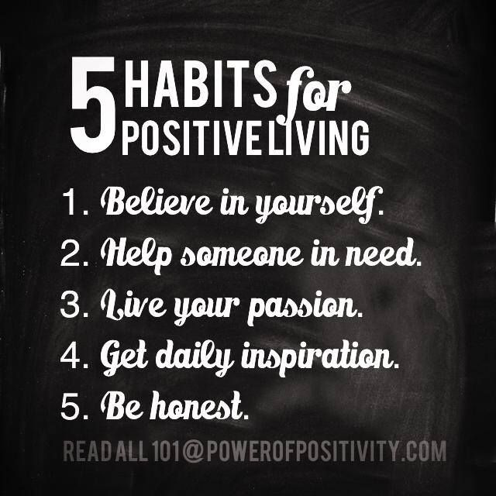
- Think of times when you have overcome challenges.

Behaviours which promote positive thinking
- Gratitude Journal- this is to list good things experienced each day, it is also helpful to list 3-5 things you are grateful for each day. This is easier to keep up with if you set a time aside each day to complete it.
- Gratitude visit- think of someone who has done something you are grateful for, write them a letter about how it made you feel and then deliver it personally and wait until they read it.
- Act of Kindness- do something nice for someone each day, this does not have to be someone you know. It could be helping someone with directions, paying for someone’s coffee, helping a neighbour carrying shopping etc.
- Develop Meaning- write a story of your past, including things which you have overcome. Then write a story of your present and how you are different from in the past. Lastly write a story about you in the future, what you have achieved, how far you have come and how you have overcome any challenges. Save these stories and update them as you grow.
- Design a Beautiful Day- map out a day you would like to experience, others can be included, break your normal routine and include small details. Accept that the day may not be exactly as you planned and feel OK about this.
- Include meditation and mindfulness into your every day.



Free mindfulness apps include Calm and Headspace; these can be tailored by age.

